# Cochise School District No. 26

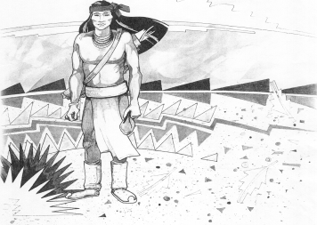

5025 N. Bowie Ave.

P.O. Box 1088

Cochise, AZ 85606

(520) 384-2540 (520) 384-4836 Fax

*Karl Uterhardt, Superintendent*

NOTICE & AGENDA OF GOVERNING BOARD MEETING

COCHISE ELEMENTARY SCHOOL DISTRICT NO. 26

Notice is hereby given that the School District Governing Board will hold a public meeting on

June 25, 2025, at 6:00pm in the Cochise Elementary School Library.

The agenda for the meeting is as follows:

I. Call to Order Time _________

1. Pledge of Allegiance to the Flag
2. Adoption of Agenda Motion ____/____Vote____
3. Call to the Audience (3 minute limit)
4. The Governing Board may vote to go into Executive Session under A.R.S. 38-431.03 (A)(3) to receive legal advice either in person or telephonically, on any item on the Consent or Action agenda.

VI. Consent Agenda

1. Approve minutes of Regular Meeting of May 7, 2025
2. Approve fund balances report for May 2025
3. Policy Advisories 819-862 first reading
4. Policy GDD Support staff vacations and holidays first reading
5. Approve vouchers # (Payroll) & # (Expense) Motion ____/____Vote____

1. Action Agenda
2. Approval of FY26 Proposed Budget Motion____/____ Vote____
3. Approval of Mrs. Kaylee Retana, Reading Interventionist FY26 Motion____/____ Vote____
4. Approve St. David Consortium SY25-26 Motion____/____ Vote____
5. Approval of Bus Repair RFP bids for SY25-26 Motion____/____ Vote____
6. Approval of IT bids for SY25-26 Motion____/____ Vote____
7. Approval of one year Audit Bid for FY25 Motion____/____ Vote____
8. Approval for carpeting work for eight classrooms Motion____/____ Vote____
9. Approval of Fence Bid SE property Motion____/____ Vote____
10. Update on Board Member search Discussion Only

VIII. Summary of reports about current events

A. Superintendent’s Report

1. July calendar of events: Office closed July 3-4, School starts August 6th.

2. Next Board meetings: July 9, August 6, September 3

B. Governing Board member’s report

IX. Adjourn Motion ____/____Vote____ Time ____